# CO2 emissions from the Central Plains urban agglomeration in China and their reduction pathways

Li Li1,2,3,4, Yuli Shan2,*, Yalin Lei1,3*, Sanmang Wu1,3, Dabo Guan2

1 School of Humanities and Economic Management, China University of Geosciences, Beijing, 100083, China

2 Water Security Research Center, Tyndall Center for Climate Change Research, and School of International Development, University of East Anglia, Norwich NR4 7TJ, UK

3 Key Laboratory of Carrying Capacity Assessment for Resource and Environment, Ministry of Land and Resources, Beijing, 100083, China

4 State Key Laboratory of Water Resource Protection and Utilization in Coal Mining, Beijing, 100011, China

* Corresponding authors: [y.shan@uea.ac.uk](mailto:y.shan@uea.ac.uk) (Shan YL); leiyalin@cugb.edu.cn (Lei YL)

## Abstract

With high coal consumption and strong economic vitality, China’s Central Plains urban agglomeration is the key area to reduce CO2 emissions. To provide references for emission reduction, this paper makes clear the evolution characteristics of CO2 emissions in 29 cities based on the latest available data from 2000 to 2015. The results indicate that (1) CO2 emissions in two coal-based cities (Changzhi and Pingdingshan) were higher than those of other cities in the same year because of larger coal consumption. CO2 emissions in coal-based cities (Pingdingshan, Xingtai) and an industrialized city (Luoyang) reached their peaks in 2011; (2) emission intensity in Changzhi was the largest due to its highest CO2 emissions and relatively lower GDP in the same year; (3) Changzhi had the biggest CO2 emissions per capita in 2014 and CO2 emissions per capita in Pingdingshan and Luoyang reached their peaks in 2011; (4) CO2 emissions from coal consumption accounted for more than 50%, the ratios, which even exceeded 94% in some cities; (5) CO2 emissions from coal mining and dressing, production and supply of electric power steam and hot water were higher. CO2 emissions accounting of 29 cities has supplemented CO2 emissions at the urban level and they provide a data base and emission reduction policies in the central plains urban agglomeration.

**Keywords**: CO2 emissions; emission intensity; CO2 emissions per capita; evolution characteristics; emission reduction;

## 1. Introduction

Climate change is a common challenge and core issue which humans face in the 21st century. Tackling climate change and promoting green and low-carbon development has aroused worldwide concerns. China has the highest CO2 emissions in the world [1]. As a responsible developing country, China will not only regard the development of low carbon as an international obligation to actively deal with climate change, but also as inherent requirements to realize its sustainable development. In 2009, the government proposed to reduce CO2 emissions per capita of GDP by 40% to 50% till 2020 compared with 2005 [2]. The National Development and Reform Commission also issued a notice which proposed to develop low-carbon industries, build low-carbon cities, advocate low-carbon living, and organize the pilot work of low-carbon provinces and regions and low-carbon cities in July 2010 [3]. China first came up with a plan to reach its CO2 emissions peak around 2030 as soon as possible and planned to increase its share of primary energy consumption to about 20% by 2030 in November 2014. To address the growing urbanization and urban greenhouse gas emissions, China has launched the Climate Smart/Low Carbon cities initiative [4]. The Chinese central government also mentioned that China would try to reach its CO2 emissions peak in 2030 and strive to achieve this goal as soon as possible in the climate change conference in Paris in November 2015 [5]. The Global Carbon Project released the Global Carbon Budget report at the UN Climate Change Conference in Bonn in November 2017, which mentioned that China's CO2 emissions accounted for 28% of the world's emissions in 2016, more than a quarter of the world’s total CO2 emissions [6].

The urbanization rate in China changed rapidly from 17.92% in 1978 to 58.52% in 2017 [7]. At present, the development of urbanization in China is in the middle stage of a rapid development. China's urbanization process will proceed at a high speed in the next decade or more. Cities are consumption places of energy and resources, and they are also the places of greenhouse gas emissions. They cover only 2% of the earth’s surface, but the population from the cities accounts for 50% in the world and the greenhouse gas emissions from the cities account for 80% in the total gas emissions [8, 9]. Cities play important roles in tackling the challenges of global climate change and they will still be the main source of China's CO2 emissions growth in the future [10]. Therefore accurate accounting of urban CO2 emissions is the first and most important step in implementing emission reduction policies and measures.

The Central Plains urban agglomeration is intended to be a national urban agglomeration with high resource allocation efficiency, strong economic vitality, competitiveness and influence. The Central Plains urban agglomeration is the key to the strategy implementation of promoting the rise of the central region, providing the strategic support for the construction of the "The Belt and Road Initiative" and promoting the coordinated development between the East and the West. It is located in central China, which is the largest, the most integrated and the most densely populated urban agglomeration among the Yangtze River Delta, the Pearl River Delta and the Beijing-Tianjin-Hebei. It covers 30 cities in Henan, Shanxi, Hebei, Shandong and Anhui [11]. Its energy consumption is great and its high CO2 emissions characteristic is obvious [12]. In the era of low carbon economy, it is very urgent to realize low carbon transformation in the Central Plains urban agglomeration.

Based on the background above and the latest availability data, this paper calculates the CO2 emissions from 29 cities in the Central Plains urban agglomeration from 2000 to 2015, with the method developed in China Emission Accounts and Datasets (CEADs) team. [13]. The paper then analyzes the cities’ detailed CO2 emissions produced by different energy and sectors, as well as the emission intensity and CO2 emissions per capita to provide specific suggestions for low-carbon development.

## 2. Literature review

The scientific and reasonable accounting of CO2 emissions is the foundation of formulating emission reduction strategies. Many scholars have calculated CO2 emissions at the national or provincial scale [1, 14-19], and sector or industries scale [20-26].

For CO2 emissions at the urban scale, research has focused on CO2 emissions in using different methods. Kennedy et al. used the methodology and data to determine the emissions attributable to ten cities or city-regions, and the factors like electricity, fuels, industrial processes and waste were demonstrated to have the attribution to the emissions of the cities [27-29]. Ramaswami et al [30] developed a demand-centered, hybrid life-cycle-based method to assess city-scale emissions, using Denver and Colorado as examples. The method can be used to estimate energy use in various city and sectors. Utilizing a hybrid life cycle-based trans-boundary emissions footprint, Hillman and Ramaswami [31] estimated the emissions for 8 US cities. The method merged end-uses of energy into city boundaries, added cross-boundary demand for airline/freight transport and embodied energy of four key urban materials in the cities. Using a hybrid pattern of production and consumption, Cai [32] proposed the cities’ emissions inventory and comparatively analyzed the characteristics of Beijing and New York’s CO2 emissions. The results indicated New York's total CO2 emissions were slightly lower than those of Beijing, while its CO2 emissions per capita were slightly higher. However, there were different viewpoints on the cities’ CO2 emissions. Dodman [33] identified these patterns of emissions by city/sector and assessed the role and potential for cities to reduce global emissions. While the results indicated emissions per capita from cities were lower than the average for the countries where they were located. Dahal and Niemelä [34] utilized amendable emissions accounting systems excluding certain amounts of emissions from several sectors to calculate greenhouse gas in Helsinki (Finland), Stockholm (Sweden) and Copenhagen (Denmark). Emission calculation methods were considered to improve to obtain more precise results.

There has been research on CO2 emissions in China’s cities. Sugar et al. [35] offered detailed emissions inventories for Beijing, Shanghai, and Tianjin and found most emissions were from electricity production, heating and industrial fuel use and ground transportation. Utilizing a bottom-up approach, Wang et al. [36] made comprehensive emissions inventories for twelve cities in China. Their results indicated that more than 60% CO2 emissions came from industrial energy consumption. Yu et al. [37] adopted a method with the Sustainable Energy Action Plan to calculated CO2 emissions in China’s four highly urbanized cities from 2004 to 2010. The results indicated the CO2 emissions were rising all the time and the secondary industry made the most contributions in the whole CO2 emissions. Xu et al. [38] estimated the CO2 emissions from the fossil fuel combustion and industrial processes of 18 central cities in China from 2000 to 2014, which considered that these 18 cities contained an average of 6.57% of the total population, 7.91% of the GDP and made a 13% contribution of China's total CO2 emissions. Using the data representing 637 Chinese cities, Ramaswami et al. [39] considered that cross-sectoral strategies were helpful and they could contribute an additional 15%–36% to CO2 mitigations. Li et al. [40] comprehensively evaluated CO2 emissions in Beijing and demonstrated that emission intensity, production input and output structure change contributed to CO2 emissions decrease. Shan et al. [41] presented new, city-level calculation of CO2 emissions for 182 Chinese cities, and the results demonstrated that more affluent cities had relative lower CO2 emissions per GDP unit.

From the literature above, it can be seen that not all cities have an estimation of CO2 emissions. There are currently few CO2 emissions accounting for the Central Plains urban agglomeration. Meanwhile, the Central Plains urban agglomeration is also under great pressure to reduce CO2 emissions. Therefore, in order to provide suggestions for emission reduction for the Central Plains urban agglomeration, based on the method of Shan et al. [13], this paper makes estimation of CO2 emissions from 2000 to 2015 and offers a supplement and improvement for CO2 emissions accounting at the urban level and provides advice for emissions reduction.

## 3. Method and data

### 3.1 CO2 emissions accounting boundary

The territorial scope for CO2 emissions accounting of every city here is made according to the guidelines in the Intergovernmental Panel on Climate Change (IPCC). Due to Luohe’s lack of energy-related data, the accounting of CO2 emissions in the paper doesn’t cover Luohe (as shown in figure 1).

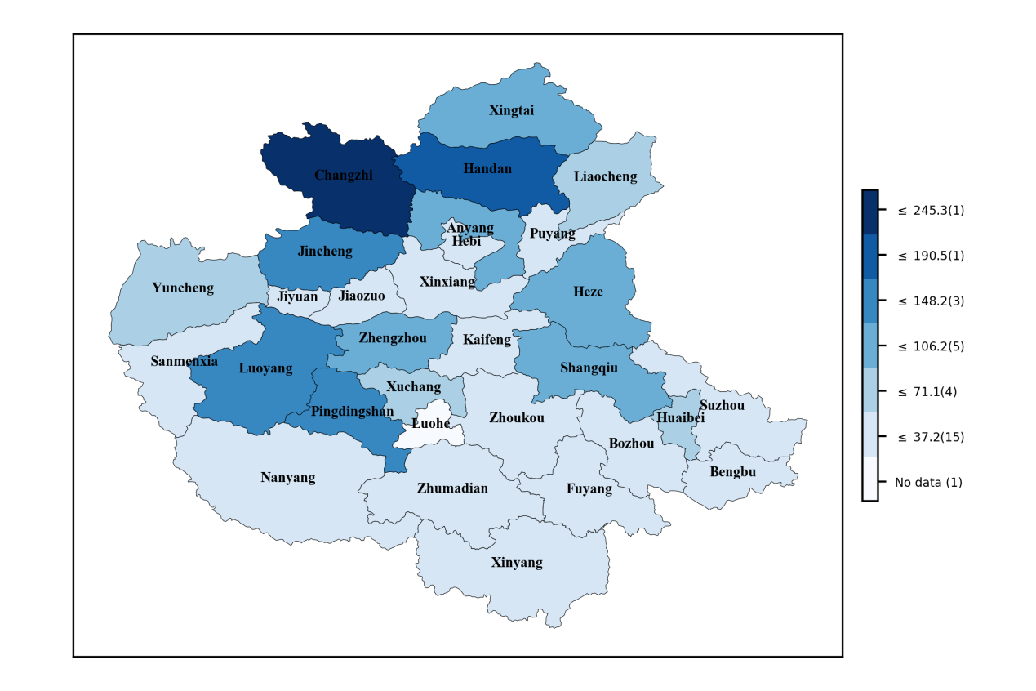

**Fig.1.** The location of the Central Plains urban agglomeration and its CO2 emissions in 2014 (Mt)

### 3.2 Construction of CO2 emissions accounting inventory

The inventory of CO2 emissions is the basis for the establishment of climate models, the formulation of national emission reduction policies and international negotiations. Current national and global CO2 emissions are estimated based on IPCC methods and energy statistic data by international agencies. The parameters and methods of estimating CO2 emissions mainly come from the statistics of developed countries and may misestimate China's CO2 emissions. Based on the theory of matter conservation and the energy balance sheet, the CEADs team has developed a CO2 emission inventory model for multiple scales in China (national, province, and prefecture-level city) and adopted actual measured emission factors [42] which are more consistent with China's energy quality. Systematically compiling China's multi-scale CO2 emission inventory can accurately measure regional CO2 emissions in order to analyze the characteristics of urban CO2 emissions in China.

In general, the accounting for CO2 emissions consists of the emissions from energy-related (${CE}_{energy}$) and industrial process (${CE}_{process}$). According to the IPCC method [43], CO2 emissions are equal to the multipliers of the activity data (AD) and the emission factors of energy (EF).

Formula 1 is used to calculate CO2 emissions which are related to energy. ${CE}_{ij}$ denotes the CO2 emissions derived from the i-th energy in sector j. ${AD}_{ij}$ represents the consumption of i-th fossil fuel in sector j and ${EF}_{i}$ refers to the emission factors of i-th energy.

${CE}_{energy}=\sum_{j}{\sum_{i}{{CE}_{ij}}}$

$=\sum_{j}{\sum_{i}{\left({AD}_{ij}×{NCV}_{i}×{EF}_{i}×O_{ij}\right)}}$

$i∈\left[1,17\right], j∈[1,47]$ (1)

Where, i indicates 17 kinds of energy (Table 1), and j manifests 47 sectors (Appendix 1). Emissions factors of fossil fuel combustion are shown in table 1.

**Table 1**

Emissions factors of fossil fuel combustion

|  |  |  |
| --- | --- | --- |
| Energy types (i) (ton CO2/TJ) | | |
| 1 raw coal | 0.21 | 96.51 |
| 2 cleaned coal | 0.26 | 96.51 |
| 3 other washed coal | 0.15 | 96.51 |
| 4 briquettes | 0.18 | 96.51 |
| 5 coke | 0.28 | 115.07 |
| 6 other coking products | 0.28 | 100.64 |
| 7 coke oven gas | 1.61 | 78.8 |
| 8 other gas | 0.83 | 78.8 |
| 9 liquefied petroleum gas | 0.51 | 63.07 |
| 10 crude oil | 0.43 | 73.63 |
| 11 gasoline | 0.44 | 69.3 |
| 12 kerosene | 0.44 | 71.87 |
| 13 diesel oil | 0.43 | 74.07 |
| 14 fuel oil | 0.43 | 77.37 |
| 15 refinery gas | 0.47 | 73.33 |
| 16 other petroleum products | 0.43 | 74.07 |
| 17 natural gas | 3.89 | 56.17 |

Source: Liu et al. [42], Shan et al. [44]

Formula 2 is used to estimate CO2 emissions which are related to industrial process. is CO2 emissions from the t-th industrial process, ${AD}_{t}$ indicates the production of the t-th industrial process, ${EF}_{t}$ represents the corresponding emission factor, and t represents industrial process in table 2.

${CE}_{process}=\sum_{t}{{CE}_{t}=\sum_{t}{\left({AD}_{t}×{EF}_{t}\right), t∈[1,9]}}$ (2)

Accordingly, the activity data contain ${AD}_{ij}$ and ${AD}_{t}$. The energy balance table covers the total different kinds of fossil fuel consumption (${AD}_{i}$). Using the energy consumption data of different industries, the total amount can be divided into 47 sectors and ${AD}_{ij}$ can be obtained. Therefore, the core data needed to compile an emission inventory includes the energy balance table (EBT), the energy consumption data from different sectors in the industry (IS) and ${AD}_{t}$.

**Table 2**

Emission factors in 9 main industrial processes

|  |  |  |
| --- | --- | --- |
| Number Industrial process ${EF}_{t}(ton {CO}_{2}/t)$ | | |
| 1 | Ammonia production | 1.5000 |
| 2 | Soda Ash production | 0.4150 |
| 3 | Cement production | 0.2906 |
| 4 | Lime production | 0.6830 |
| 5 | Ferrochromium production | 1.3000 |
| 6 | Silicon metal production | 4.3000 |
| 7 | Ferro-unclassified production | 4.0000 |
| 8 | Ferrous Metals production (Coke usage as reducing agent) | 3.1000 |
| 9 | Nonferrous Metals production (Coke usage as reducing agent) | 3.1000 |

Source: Shan et al.[13]

### 3.3 Uncertainty analysis

There are many uncertain factors affecting the estimation of urban CO2 emissions, such as the impacts of basic data of energy consumption statistics and the activity level, statistical methods, the numbers selection of emission factors in the calculation process, unreasonable statistical data, etc. This can have impacts on the estimation of CO2 emissions at the city level. Also, it is difficult to obtain some data for activity levels directly, such as the amount of urban solid waste production. These are the differences with the actual situation of the cities, which will affect the reliability of the calculation results. After calculations, the uncertainty analysis for CO2 emissions in 29 cities ranged from -5.8% to 3.9%.

### 3.4 Data source

The latest available data from 2000 to 2015 are collected from the cities' statistical yearbook, all the data used and the results will be online at CEADs, (www.ceads.net). The indicators cover GDP (the primary, secondary and tertiary industries), the population of prefecture-level cities and provinces (urban population and rural population), the output of industrial products, ${AD}_{ij}$, the total industrial output value above a designated scale and the total industrial output value. Where the statistical yearbooks of the 29 cities have available data, they were utilized directly in the calculation. If not, they were handled according to the methods from Shan et al. [13]. GDP data here are standardized to the currency values for the year 2000.

## 4. Results and discussion

### 4.1 CO2 emissions calculation

4.1.1 Annual total CO2 emissions in 29 cities from 2000 to 2015

According to the different trends of CO2 emissions from 2000 to 2015, the 29 cities are roughly divided into 4 categories. From the results, it can be seen that the CO2 emissions trends of 7 cities appeared to abrupt fluctuation, 9 cities trended steadily upward, emissions in 10 cities rose at first and then decreased and in 3 cities emissions were relatively stable (Figure 2).

 **Fig. 2.** CO2 emissions in 29 cities from 2000 to 2015 (Mt).

Anyang: CO2 emissions in the 7 cities with a trend of abrupt fluctuation

Jiyuan: CO2 emissions in the 9 cities with a trend of steady upward

Jiaozuo: CO2 emissions in the 10 cities with a trend of rising at first and decreasing then

Puyang: CO2 emissions in the 3 cities with a trend of relative stability

As can be seen from Figure 2, of the 7 cities with the trend of abrupt fluctuation, Handan had the highest CO2 emissions in each year, and the gap with other 6 cities grew larger year on year. The total CO2 emissions in Handan increased from 106.41 Mt in 2000 to 185.36 Mt in 2015. CO2 emissions in Jincheng grew rapidly from 19.54 Mt in 2002 to 137.36 Mt in 2015, the annual growth rate of which was as high as 15.3%, the second highest of the 29 cities. Handan and Jincheng are two coal-based cities, whose emissions both reached the highest point of the 2000-2015 period in 2014. Handan reduced its coal consumption and cement capacity in 2015. Jincheng issued its low-carbon development plan in 2014, requiring industrial restructuring, energy restructuring and carbon reduction projects in key areas [45]. The plan was so efficient that CO2 emissions were lower in 2015.

In the 9 cities with the trend of steady upward, Shangqiu had the highest CO2 emissions from 2004 to 2010. CO2 emissions in Huaibei were higher than other 8 cities (except Shangqiu, without data) after 2010. Huaibei is also a famous coal-based city. The higher CO2 emissions were due to a relative higher ratio of coal consumption in the energy structure, accounting for more than 94% of CO2 emissions. The annual change of CO2 emissions in Kaifeng was the smallest, increasing from 7.24 Mt in 2000 to 16.52 Mt in 2014, which might be due to its declining industry and booming tourism.

There were trends of first rising and then decreasing in CO2 emissions in 10 cities. CO2 emissions of Changzhi and Pingdingshan were higher than those of other cities in the same year. CO2 emissions in Pingdingshan reached the highest point in 2011 (204.03 Mt) and there has been a downward trend since 2011. With the control of coal production and consumption and emission reduction policies in the future, it can be expected that CO2 emissions in Pingdingshan will not be higher than those in 2011. CO2 emissions in Changzhi reached a peak of 245.28 Mt in 2014 and then decreased to 227.38 Mt in 2015. CO2 emissions of Luoyang (130.91 Mt) and Xingtai (122.05 Mt) both peaked in 2011 and showed a downward trend after 2011. CO2 emissions of Jiaozuo and Xingtai appeared on a downward trends, which indicated that the emission reduction policies were effective in these two cities. However, due to their larger coal consumption and industrial cities bases, the effects were small.

In the 3 cities with a trend of relative stability, CO2 emissions showed a steady tendency as a whole. CO2 emissions in Xinxiang were relatively higher compared with the other two cities, changing from 29.82 Mt to 38.96 Mt between 2007 and 2015. The change trends of CO2 emissions in Puyang and Fuyang were generally consistent and they both did not exceed 20 Mt from 2004 to 2015. The average annual growth rates of CO2 emissions were 0.64% (the lowest in the 29 cities), 3.40% and -2.40% in 2015 respectively. It could be seen that the overall CO2 emissions of Fuyang showed a downward trend, but the decline rate was relatively small.

Seen from CO2 emissions in different kinds of energy and industrial process, CO2 emissions from coal consumption in Anyang, Hebi, Handan, Jincheng and other coal-based cities were higher than 90%, which were mainly due to the coal industry. CO2 emissions from oil consumption in the industrialized city of Luoyang, the oil cities of Nanyang and Puyang were higher than other cities, mainly due to their greater demand for oil and oil cities. The following section discusses CO2 emissions in different energy and industrial process in details in 2015.

4.1.2 Emission intensity

Emission intensity indicates the amount of CO2 emissions emitted by GDP per capita. It is mainly used to measure the relationship between urban economy and CO2 emissions.

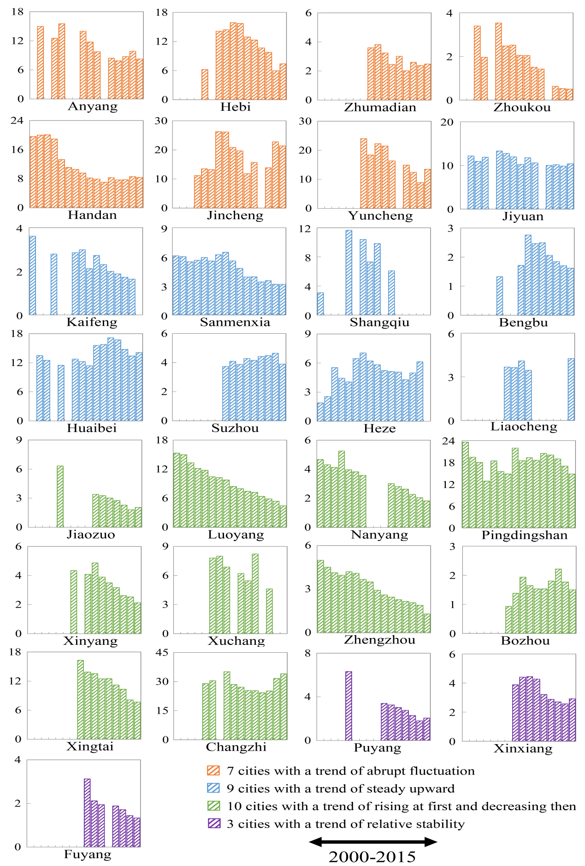

**Fig. 3.** Emission intensity in 29 cities from 2000 to 2015 (ton/ten thousand yuan).

For the 7 cities with the trend of abrupt fluctuation, except for an individual year, the emission intensity of Handan, Zhoukou and Zhumadian cities had roughly shown downward trends, indicating the ratio of GDP increasing was higher than that of CO2 emissions. The three cities were on the way to low-carbon development. The CO2 emission intensity trends of other 4 cities were the same as the trend of their CO2 emissions, showing an unsteady trend of declining and rising alternately.

As for the 9 cities with the trend of steady upward, the emission intensity of Huaibei was bigger than of the other 8 cities, which varied between 11.38 to 17.16 tons/ten thousand yuan. When CO2 emissions in Huaibei were similar to those in some other cities, the emission intensity was relatively larger due to its relatively smaller GDP, the same as Jiyuan. The changes in the emission intensity of Kaifeng, Handan, Suzhou, Liaocheng, and Heze were all relatively stable within the period, indicating that the changes in CO2 emissions were synchronized with changes in their GDP.

For the 10 cities with the trend of rising at first and decreasing then, emission intensity in Changzhi, Pingdingshan, and Xingtai were relatively higher between 2000 and 2015. The emission intensity in Changzhi was the largest of the 29 cities in the same year. It had ranged between 24.24 and 34.03 tons/ten thousand yuan in 2004-2015. Pingdingshan, whose emission intensity was also larger, varying from 12.86 to 23.6 tons/ten thousand yuan between 2000 and 2015. Emission intensity trends in Changzhi, Pingdingshan, and Xuchang had shown unsteady change trends. While, Jiaozuo, Luoyang, Nanyang (except 2003), Xinyang (except 2009), Zhengzhou, and Xingtai showed declining trends roughly, indicating that these cities had significant emission reduction effects. The emission intensity of Bozhou could be regarded as a relatively stable change due to its relatively small value, which was between 0.93 and 2.21 tons/ ten thousand yuan.

For the 3 cities with the trend of relative stability, Puyang and Fuyang demonstrated general downward trends. The emission intensity in Puyang fell from 6.33 tons/ten thousand yuan in 2004 to 1.80 tons/ten thousand yuan in 2014, and rose to 2.05 tons/ten thousand in 2015. The emission intensity of Fuyang steadily declined from 3.12 tons/ten thousand yuan in 2008 to 1.34 tons/ten thousand yuan in 2015, indicating that emission reduction policies were useful in Fuyang. The volatility in Xinxiang ranged from 2.57 to 4.44 tons/ten thousand yuan, implying the changing trends in CO2 emissions were consistent with those in GDP.

4.1.3 CO2 emissions per capita

It can be seen from Figure 4, in the 7 cities with the trend of abrupt fluctuation, the total CO2 emissions in Jincheng were not the highest, but due to its smaller population its CO2 emissions per capita were the largest compared to other cities in the same year, increasing from 9.22 tons/per capita in 2003 to 62.74 tons/per capita in 2014. Subsequently, it fell slightly to 56.65 tons/per capita in 2015. CO2 emissions per capita in Anyang, Handan and Yuncheng had not changed much, mainly because their ratios of CO2 emissions to population had not changed significantly.

In the 9 cities with the trend of steady upward, CO2 emissions per capita in Jiyuan were relatively larger and trended upward, rising from 12.55 to 47.65 tons/per capita in 2001-2015, likely related to its small population. Jiyuan’s population was only a few hundreds of thousands. CO2 emissions per capita in Huaibei generally rose from 7.76 to 33.83 tons/per capita in 2001-2015, and the overall trend was upward except a slight declining in some years. That is mainly because of its relatively larger CO2 emissions and lower population. There was minimal change in the CO2 emissions per capita of Kaifeng, Shangqiu, Bengbu, Suzhou, and Liaocheng (except 2015), primarily as they had stable CO2 emissions and population.

 In the 10 cities with the trend of rising at first and decreasing then, CO2 emissions per capita in Changzhi and Pingdingshan were also relatively higher. CO2 emissions per capita in Changzhi jumped from 27.21 to 72.04 tons/per capita in 2014, while they fell to 67.50 tons/per capita in 2015. Pingdingshan, whose CO2 emissions per capita peaked (38.6 tons/per capita) in 2011 and have been declining since 2011. It can therefore be expected that CO2 emissions per capita in Pingdingshan will not be higher than that in 2011. Similar to Pingdingshan, Luoyang also achieved its highest point (19.93 tons/per capita) in 2011. It can also be considered to have peaked. Similarly, there were few changes for CO2 emissions per capita in Jiaozuo, Nanyang, Xinyang, Xuchang, Zhengzhou, and Bozhou year on year. There were no significant changes for CO2 emissions and population in these cities. Bozhou especially has the lowest CO2 emissions per capita compared to other cities in the same year, varying from 0.45 ton/per capita to 2.15 tons/per capita.

 In the 3 cities with the trend of relative stability, the change trends of CO2 emissions per capita appeared steady. CO2 emissions per capita in Puyang and Xinxiang changed from 4.24 to 6.81 tons/per capita between 2004 and 2015. While CO2 emissions per capita in Fuyang remained basically unchanged, which were approximately 1.5 tons/per capita.

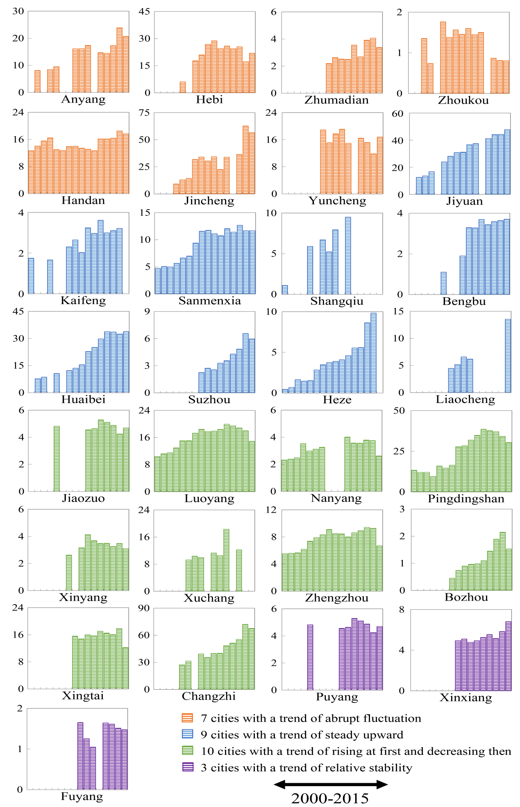

**Fig. 4.** CO2 emissions per capita in 29 cities from 2000 to 2015 (ton/per capita).

### 4.2 CO2 emissions from different energy and industrial processes in 2015

The total emissions are divided into coal-related, oil-related, gas-related, and process-related emissions in Figure 5. This paper uses the more complete and the latest data from 2015 to explore CO2 emissions from three kinds of energy and industrial processes.

**Fig. 5.** CO2 emissions from different kinds of energy and industrial process in 2015 (Mt)

For the 7 cities with a trend of abrupt fluctuation, CO2 emissions from coal consumption accounted for the highest proportion in Anyang, Hebi, Handan, Jincheng (higher than 90%), related to their coal resources-based background. Especially notable, CO2 emissions from coal consumption in Jincheng were as high as 96.64%. The lowest proportion of CO2 emissions generated by coal consumption was 53.44%, which was from Zhoukou (3.78 Mt). For oil, CO2 emissions from oil consumption in Zhoukou were about 2.39 Mt, but the proportion of emissions accounting for energy consumption was the highest (33.81%). CO2 emissions from oil consumption in the other cities in this group accounted for about 2%. Similar to oil consumption, the proportion of CO2 emissions generated by gas consumption in Zhoukou was higher (5.4%). However, the proportion of emissions from gas consumption in the other 4 cities was smaller than 1%.

For the 9 cities with a trend of steady upward, as Kaifeng, Shangqiu, Huaibei and Heze didn’t have the energy consumption data in 2015. Therefore this paper estimated their CO2 emissions in 2015 according to the data from 2000 to 2014. The highest proportions of CO2 emissions from coal consumption were in Jiyuan, Shangqiu, Huaibei and Liaocheng, which accounted for more than 94%. Shangqiu, Huaibei and Liaocheng are coal-based cities and coal plays an important role in the local economy. The coal industry is still in transition, while a local service industry has not yet formed. The higher proportion of CO2 emissions from coal consumption in Jiyuan is mainly due to consumption from its heavy industry and key enterprises. For oil, the highest proportion of CO2 emissions from oil consumption was in Heze (26.92%) and Bengbu (14.6%).

For the 10 cities with a trend of rising at first and decreasing then, Xuchang didn’t have the energy consumption data in 2015, therefore this paper estimated its CO2 emissions in 2015 according to the data from 2005 to 2013. The ratios of CO2 emissions from coal consumption in Changzhi, Pingdingshan and Xingtai were the highest (more than 93%), as these three cities are also coal-based cities, especially Changzhi. CO2 emissions from coal consumption in Changzhi were up to 224 Mt, accounting for 98.51% of its total CO2 emissions in 2015. For oil, the ratio of CO2 emissions from oil consumption in Nanyang was the largest (33.81%). Nanyang is also famous for the Nanyang oil field, accounting for energy consumption mainly based on oil.

For the 3 cities with a trend of relative stability, the ratios of CO2 emissions from coal consumption in Puyang, Xinxiang and Fuyang accounted from 52.3%, 68.62% and 63.76%. The ratio of CO2 emissions from coal consumption in Puyang were not as high as it consumed more oil. In Xinxiang, as an industrialized city, the secondary industry accounts for a large proportion and it consumes more coal resources, which has a greater influence on CO2 emissions. Similar to Nanyang, Puyang owns the Central Plains oil field, so its oil consumption was higher and CO2 emissions from oil consumption were relatively greater (5.58 Mt, 30.35%).

### 4.3 CO2 emissions produced by sectors in 2015

CO2 emissions produced by different sectors in the 29 cities were significantly different in 2015. In order to analyze the effects of some key industries development on CO2 emissions, this paper merged 45 sectors into 9 sectors.

**Fig. 6.**  CO2 emissions produced by different sectors in 2015 (Mt)

For the 7 cities with a trend of abrupt fluctuation in Figure 6, except Zhoukou, CO2 emissions from other 8 sectors accounted for more than 80% in the total emissions. The highest ratios of CO2 emissions from coal mining and dressing were 53%, 9% and 8% in Hebi, Jincheng and Handan, respectively. This is because these three cities are coal resource-based cities and coal mining and dressing is their main sector. As for petroleum processing and coking, Yuncheng, Anyang, and Jincheng’s proportions of CO2 emissions from petroleum processing and coking were 40%, 35%, and 29%, indicating that close attention needs to be paid to petroleum processing and coking for emissions reductions. The ratios of CO2 emissions from smelting and pressing of ferrous metals in Handan and Anyang accounted for 60% and 49% of the total emissions, while the ratios in other cities were smaller. Production and supply of electric power, steam and hot water in Zhumadian (44%), Jincheng (40%), Hebi (35%) has the highest ratios of CO2 emissions.

For the 9 cities with a trend of steady upward, the ratio of CO2 emissions generated by coal mining and dressing in Huaibei was as high as 81%, which was related to the typical coal resource-based city. Kaifeng had a relatively higher CO2 emissions produced by raw chemical materials and chemical products (35%), as it is one of the 14 chemical bases in China. Production and supply of electric power, steam and hot water also had a relatively larger share in CO2 emissions in these cities, such as Jiyuan (45%), Kaifeng (31%), Sanmenxia (35%), Shangqiu (40%), and Chongqing (46%), Huaibei (10%), Suzhou (23%), Heze (33%), Liaocheng (56%).

For the 10 cities with a trend of rising at first and decreasing then, the proportions of CO2 emissions from coal mining and dressing in Changzhi (118.92 Mt) and Pingdingshan (60.93 Mt) were 52% and 46% respectively, as they are typical coal resource-based cities and coal mining and dressing is their main sector. Production and supply of electric power, steam and hot water industry also has a relatively larger proportion of CO2 emissions in Jiaozuo (28%), Luoyang (54%), Nanyang (32%), Pingdingshan (30%), Xinyang (52%), Xuchang (37%), Zhengzhou (41%), Xingtai (21%), and Changzhi (23%) except Zhangzhou (7%). Regarding transportation, storage, post and telecommunication services, Zhengzhou has the largest ratio of CO2 emissions (9%) of the 29 cities. Because Zhengzhou is the only core city in the Central Plains urban agglomeration, it has also has heavy traffic.

For the 3 cities with a trend of relative stability, Xinxiang’s coal mining and dressing generated the largest amount of CO2 emissions (9.77 Mt, 25%) of all sectors. The production and supply of electric power, steam and hot water also has a relatively larger proportion in CO2 emissions in Puyang (44%), Xinxiang (26%) and Puyang (42%). CO2 emissions generated by transportation, storage, post and telecommunication services were also smaller.

## 5. Conclusions and policies

This paper estimates CO2 emissions, emission intensity and CO2 emissions per capita in 29 cities from 2000 to 2015. These vary due to the differences in energy consumption, urbanization process and other factors. The main conclusions and policies are as follows.

### 5.1 Conclusions

There are large differences in the total CO2 emissions and the shares of various sectors in different cities. On the whole, CO2 emissions and emission intensity in the northwestern part are relatively larger than those in the southeast, and the overall low carbon level is relatively lower. CO2 emissions in two coal-based cities (Changzhi and Pingdingshan) were higher than those of other cities in the same year because of larger coal consumption. CO2 emissions in coal-based cities (Pingdingshan, Xingtai) and an industrialized city (Luoyang) reached their peaks in 2011, when China's regulation of the real estate sector affected other sectors of the national economy, leading to a slowdown in the demand for coal consumption and the end of the golden decade for the coal industry. The emission intensity in Changzhi was the largest due to its highest CO2 emissions and relatively lower GDP in the same year, demonstrating that there is still a long way to go to achieve low-carbon development. Changzhi had the biggest CO2 emissions per capita in 2014 and CO2 emissions per capita in Pingdingshan and Luoyang reached their peaks in 2011. In the southeast, CO2 emissions and emission intensity were low in Zhoukou, Bozhou, Fuyang, Bengbu, Zhumadian. We therefore conclude that CO2 emissions, emission intensity and CO2 emissions per capita in coal-based cities, heavy industry cities and cities with smaller populations were relatively higher while CO2 emissions, emission intensity and CO2 emissions per capita are relatively lower in more agricultural, less developing and more populous cities.

Examining different kinds of energy and industrial processes, CO2 emissions from coal consumption accounted for a majority of the total emissions, which were basically more than 50%. The proportion of CO2 emissions from coal consumption even exceeded 94% in some coal-based cities and industrial cities like Anyang, Handan, Jincheng, Yuncheng, Shangqiu, Huaibei, Pingdingshan, Changzhi. CO2 emissions from gas were lower in all 29 cities. We therefore conclude that the industrial structure and energy consumption structure of these cities were mainly based on coal resource and relatively slower in evolution. Industrial structure, energy structure and CO2 emissions had significant correlation characteristics, which meant the CO2 emissions growth rate did not significantly slow down.

Seen from different sectors, CO2 emissions reduction potential was great, but CO2 emissions reduction was also difficult. There is a great space for industrial structure and energy structure adjustment in the Central Plains urban agglomeration. However, the energy structure of the central region is mainly based on coal resource. Hence, CO2 emissions from coal mining and dressing, production and supply of electric power, steam and hot water were higher. With rapid industrialization and urbanization, it is inevitable to bring a lot of pressure to reduce CO2 emissions, especially for those cities where emissions are on an upward trend. Compared with the other 8 sectors, CO2 emissions were not higher from transportation, storage, post and telecommunication services, which mainly because there was not very much traffic in these cities.

### 5.2 Policies

Increase the proportion of coal purification to achieve low carbon energy. Energy decarbonization is the basic guarantee for low carbon cities. The current energy structure in the Central Plains urban agglomeration is mainly based on coal resources. The proportion of coal accounting for current energy structure in some cities is higher than the national average, which is more than 60%, especially in coal-based cities such as Changzhi, Pingdingshan (maybe better to list a few more cities rather than et al.). Therefore, it is difficult to significantly reduce the proportion of coal in the short term. Vigorously developing coal purification technology is a practical strategy for low-carbon cities construction in the Central Plains urban agglomeration.

Change the energy consumption structure. The unit consumption of oil and gas generates lower CO2 emissions than coal resource. The energy consumption structure can be shifted from the traditional coal consumption structure to coal, oil and gas. These 29 cities can make good use of the “West-East Gas Transmission” project to guide the cities to restructure their energy consumption structure. Meanwhile, the cities can actively develop and utilize new and clean energy resource according to their development plans.

Use economic means to control CO2 emissions. Economic instruments include CO2 emissions trading rights [46] and taxes. Production and supply of electric power, steam and hot water can be made as the breakthrough point in boosting CO2 emissions trading rights. Then petroleum processing and coking, smelting and pressing of ferrous metals, raw chemical materials and chemical products, coal mining and dressing can be added in the future. The establishment and start-up of carbon market will affect the production of some industries and it can also affect the economic development of the cities to a certain extent, which is conducive to emission reduction.

Generally speaking, comprehensively accounting of the cities’ CO2 emissions can provide the data base for urban emissions reduction. It can also provide reference to adjust industrial structure, upgrade the sectors with the high energy consumption, ensuring the cities meet the development requirements of low-carbon cities.

### Acknowledgements

All the data and results can be download freely from China Emission Accounts and Datasets (CEADs) at http://www.ceads.net. The authors express their sincere thanks for the support from Beijing Publicity Culture High-level Talent Training Subsidy Program under Grant No. 2017XCB031, the National Natural Science Foundation of China under Grant No. 71773118, the Fundamental Research Funds for the Central Universities under Grant No. 53200759032, Teaching Research and Teaching Reform Project Funds of China University of Geosciences (Beijing) in 2017 under Grant No. JGYB201715, Open Fund of State Key Laboratory of Water Resource Protection and Utilization in Coal Mining under Grant No. SHJT-17-42.20.

### Reference

[1] Guan DB, Liu Z, Geng Y, Lindner S, Hubacek K. The gigatonne gap in China’s carbon dioxide inventories. Nature Clim. Change 2012; 2(9), 672.

[2] The State Council. Tackling climate change: China has actively promoted actions and made great contributions. 2009.

<http://www.gov.cn/jrzg/2009-12/17/content_1489577.htm> (2009-12-17)

[3] Central People's Government of the People's Republic of China. Notice on the pilot work of low-carbon provinces and cities in National Development and Reform Commission.2010.

<http://www.gov.cn/zwgk/2010-08/10/content_1675733.htm> (2010-08-10)

[4] People Website. China's CO2 emissions peaked in 2030 and the US commits to reduce CO2 emissions. 2014.

<http://politics.people.com.cn/n/2014/1113/c70731-26012421.html> (2014-11-13)

[5] Phoenix News. China pledges to reach its CO2 emissions peak around 2030.

http://news.ifeng.com/a/20151201/46471205_0.shtml (2015-12-01)

[6] Le Quéré et al.Global Carbon Budget 2017. 2017.

http://www.globalcarbonproject.org/carbonbudget/17/files/GCP_CarbonBudget_2017.pdf

[7] National Bureau of Statistics of the People's Republic of China. Domestic demand has propped up China's economic growth. 2018.

<http://www.stats.gov.cn/tjsj/sjjd/201804/t20180410_1592995.html> (2018-04-10)

[8] The United Nations Human Settlements Programme. Cities and climate change: Global Human Settlements Report in 2011. Washington, 2011.

[9] Gu CL, Tan ZB, Liu W, Yu TF, Han Q, Liu HL, et al. Research progress on climate change, CO2 emissions and low-carbon urban planning. Urban planning forum, 2009, 3: 38-45.

[10] Zhang Y. Urbanization will be the main source of China's future CO2 emission growth.

<http://news.china.com.cn/txt/2015-06/17/content_35847226.htm> (2015-06-17)

[11] National Development and Reform Commission of the People's Republic of China. The state development and reform commission issued a circular on the development planning of the central plains urban agglomeration. 2016.

<http://www.ndrc.gov.cn/zcfb/zcfbtz/201701/t20170105_834444.html> (2016-12-29)

[12] Rong PJ. Effects on urbanization development and CO2 emission in Henan. J Henan University (Natural Science) 2016; 46 (5): 514-521.

[13] Shan YL, Guan DB, Liu JH, Mi ZF, Liu Z, Liu JR, et al. Methodology and applications of city level CO2 emission accounts in China. J Clean Prod 2017; 161: 1215-1225.

[14] Shan YL, Liu JH, Liu Z, Xu XWH, Shao S, Wang P, et al. New provincial CO2 emission inventories in China based on apparent energy consumption data and updated emission factors. Appl. Energy 2016a 184, 742-750.

[15] Shan YL, Guan DB, Zheng HR, Ou JM, Li Y, Meng J, et al. China CO2 emission accounts 1997-2015. Sci Data 2017; DOI: 10.1038/sdata.2017.201.

[16] Mi ZF, Zhang YK, Guan DB, Shan YL, Liu Z, Cong RG, et al. Consumption-based emission accounting for Chinese cities. Appl. Energy 2016; 184, 1073-1081.

[17] Mi ZF, Wei YM, Wang B, Meng J, Liu Z, Shan YL, et al. Socioeconomic impact assessment of China's CO2 emissions peak prior to 2030. J Clean Prod 2017; 142: 2227-2236.

[18] Mi ZF, Meng J, Guan DB, Shan YL, Song ML, Wei YM, et al. Chinese CO2 emission flows have reversed since the global financial crisis. Nat commun 2017; 8(1): 1712.

[19] Meng J, Mi ZF, Guan DB, Li JS, Tao S, Li Y, et al. The rise of South–South trade and its effect on global CO2 emissions. Nat commun 2018; 9: 1871.

[20] Cai H, Xie SD. Estimation of vehicular emission inventories in China from 1980 to 2005. Atmos environ 2007; 41(39): 8963-8979.

[21] Shao S, Yang LL, Yu MB, Yu ML. Estimation, characteristics, and determinants of energy-related industrial CO2 emissions in Shanghai (China), 1994-2009. Energy Pol 2011; 39: 6476-6494.

[22] Lei Y, Zhang Q, Nielsen C, He KB. An inventory of primary air pollutants and CO2 emissions from cement production in China, 1990–2020. Atmos environ 2011; 45(1): 147-154.

[23] Liu Z, Geng Y, Lindner S, Zhao HY, Fujita T, Guan DB, 2012a. Embodied energy use in China's industrial sectors. Energy Pol. 49, 751-758.

[24] Liu Z. National carbon emissions from the industry process: Production of glass, soda ash, ammonia, calcium carbide and alumina. Appl. Energy 2016b; 166: 239-244.

[25] Shan YL, Liu Z, Guan DB. CO2 emissions from China’s lime industry. Appl. Energy 2016; 166: 245-252.

[26] Suryati I, Indrawan I, Alihta KN. Study of carbon dioxide emission inventory from transportation sector at Kualanamu International Airport. IOP Conference Series: Materials Science and Engineering. IOP Publishing 2018; 309(1): 012-023.

[27] Kennedy CA, Steinberger J, Gasson B, Hansen Y, Hillman T, Havranek M, et al. Greenhouse gas emissions from global cities. Environ. Sci. Technol 2009; 43: 7297-7302.

[28] Kennedy CA, Ramaswami A, Carney S, Dhakal S. Greenhouse gas emission baselines for global cities and metropolitan regions. Fifth Urban Research Symposium, Cities and Climate Change: Responding to an Urgent Agenda 2009: 28-30.

[29] Kennedy CA, Steinberger J, Gasson B, Hansen Y, Hillman T, Havránek M, et al. Methodology for inventorying greenhouse gas emissions from global cities. Energy pol. 2010; 38(9): 4828-4837.

[30] Ramaswami A, Hillman T, Janson B, Reiner M, Thomas G. A demand-centered, hybrid life-cycle methodology for city-scale greenhouse gas inventories. Environ. Sci. Technol 2008, 42: 6455-6461.

[31] Hillman T, Ramaswami A. Greenhouse gas emission footprints and energy use benchmarks for eight US cities. Environ. Sci. Technol. 2010, 44 (6): 1902–1910.

[32] Cai BF. Research on greenhouse gas emissions inventory in the cities of China. China population. Res. Environ. 2012; 22: 21-27. (in Chinese)

[33] Dodman D. Blaming cities for climate change? An analysis of urban greenhouse gas emissions inventories. Environ. Urbanization 2009; 21(1): 185-201.

[34] Dahal K, Niemelä J. Cities’ greenhouse gas accounting methods: A study of helsinki, stockholm, and copenhagen. Climate 2017; 5(2): 31.

[35] Sugar L, Kennedy C, Leman E. Greenhouse gas emissions from Chinese cities. J. Ind. Ecol. 2012; 16: 552-563.

[36] Wang H, Zhang R, Liu M, Bi J. The carbon emissions of Chinese cities. Atmos. Chem. Phys.2012; 12: 6197-6206.

[37] Yu W, Pagani R, Huang L. CO2 emission inventories for Chinese cities in highly urbanized areas compared with European cities. Energ Policy 2012; 47: 298-308.

[38] Xu XWH, Huo H, Liu JR, Shan YL, Li Y, Zheng HR, et al. Patterns of CO2 emissions in 18 central Chinese cities from 2000 to 2014. J Clean Prod, 2018, 172: 529-540.

[39] Ramaswami A, Tong K, Fang A, Lal RM, Nagpure AS, Li Y, et al. Urban cross-sector actions for carbon mitigation with local health co-benefits in China. Nat. Clim. Change 2017; 7(10):736.

[40] Li JS, Zhou HW, Meng J, Yang Q, Chen B, Zhang YY. Carbon emissions and their drivers for a typical urban economy from multiple perspectives: A case analysis for Beijing city. Appl. Energy 2018; 226: 1076-1086.

[41] Shan YL, Guan DB, Hubacek K, Zheng B, Davis SJ, Jia LC, et al. City-level climate change mitigation in China. Sci. Adv. 2018; 4(6): eaaq0390.

[42] Liu Z, Guan DB, Wei W, Steven JD, Philippe C, Bai J, et al. Reduced carbon emission estimates from fossil fuel combustion and cement production in China. Nat. 2015: 524(7565): 335-338.

[43] IPCC. IPCC Guidelines for national greenhouse gas inventories. Institute for Global Environmental Strategies, 2006.

[44] Shan YL, Guan DB, Zheng HR, Ou JM, Li Y, Meng J. China CO2 emission accounts 1997–2015. Sci. data 2018; 5: 170201.

[45] The People's Government of Jincheng City. The People's Government of Jincheng City issued a notice on the low-carbon development plan of Jincheng City (2013-2020)

<http://www.jchb.gov.cn/szffffw/26683.jhtml> (2014-07-18)

[46] Guan DB, Shan YL, Liu Z, He KB. Performance Assessment and Outlook of China’s Emission-Trading Scheme. Eng. 2016; 2(4): 398-401.

**Appendix 1**

Sector classification for city’s CO2 emission accounting

|  |  |
| --- | --- |
| Number (j) | Sectors |
| 1 | Farming forestry animal husbandry fishery and water conservancy |
| 2 | Coal mining and dressing |
| 3 | Petroleum and natural gas extraction |
| 4 | Ferrous metals mining and dressing |
| 5 | Nonferrous metals mining and dressing |
| 6 | Nonmetal minerals mining and dressing |
| 7 | Other minerals mining and dressing |
| 8 | Logging and transport of wood and bamboo |
| 9 | Food processing |
| 10 | Food production |
| 11 | Beverage production |
| 12 | Tobacco processing |
| 13 | Textile industry |
| 14 | Garments and other fiber products |
| 15 | Leather, furs, down and related products |
| 16 | Timber processing, bamboo, cane, palm fiber & straw products |
| 17 | Furniture Manufacturing |
| 18 | Papermaking and Paper Products |
| 19 | Printing and Record Medium Reproduction |
| 20 | Cultural, Educational and Sports Articles |
| 21 | Petroleum Processing and Coking |
| 22 | Raw Chemical Materials and Chemical Products |
| 23 | Medical and Pharmaceutical Products |
| 24 | Chemical Fiber |
| 25 | Rubber Products |
| 26 | Plastic Products |
| 27 | Nonmetal Mineral Products |
| 28 | Smelting and Pressing of Ferrous Metals |
| 29 | Smelting and Pressing of Nonferrous Metals |
| 30 | Metal Products |
| 31 | Ordinary Machinery |
| 32 | Equipment for Special Purposes |
| 33 | Transportation Equipment manufacturing |
| 34 | Electric Equipment and Machinery |
| 35 | Electronic and Telecommunications Equipment |
| 36 | Instruments, Meters, Cultural and Office Machinery |
| 37 | Other Manufacturing Industry |
| 38 | Scrap and waste |
| 39 | Production and Supply of Electric Power, Steam and Hot Water  (Electricity generation) |
| 40 | Production and Supply of Gas |
| 41 | Production and Supply of Tap Water |
| 42 | Construction |
| 43 | Transportation, Storage, Post and Telecommunication Services (Transportation services) |
| 44 | Wholesale retail trade and catering services (Wholesale services) |
| 45 | Urban |
| 46 | Rural |
| 47 | Others |